***Storm and Climate Data Record (SCDR)***

Implementation Plan

Date of record:

Jan 1, 2017 to Dec 1, 2019

Principal Investigator: Tricia Lang

## Introduction

### 1.1 Overview and purpose

The purpose of this report is to determine if there is a pattern between crime and storms in Miami-Dade County. This could be a helpful tool for law enforcement to predict when there may be an increase in crimes should there be a relationship between storm activity and crime. It may be useful for efforts to curb crime at specific times by increasing patrols or efforts to reduce crimes at certain times of the year or based on weather patterns.

### 1.2 Define why you need data analysis

Data analysis is important to extract information from the data, and be able to make informed decisions (import.io, 2019). In this case, the information to be extracted is to be able to make informed decisions of a predictive nature as the police department would like to be able to predict whether to anticipate future losses from crimes during hurricane season. With the raw data alone, it is not clear if there are any patterns or relationships between the data points and time.

## II. Data Preparations

### 2.1 Name data sources

The source for the data is from Miami-Dade County. One set of data is of the occurrences of crimes that occurred during storms, and the financial losses of the victims. The other set is of crimes that occurred when no storms were happening, and the financial losses of the victims. There are 36 rows of data in each set. Each row of data is matched by date, with a value for losses in each row that corresponds to each month from January of 2017 through December of 2019.

### 2.2 Filter through unnecessary data

Within the analysis, specific information may need to be filtered out to determine if there are patterns related to the time of year. This may be helpful in determining the potential interventions when the intensity of storms is anticipated to increase or decrease. All of the data in the original data sets is important for the purposes of this evaluation and none was excluded entirely.

### 2.3 Define your parameters

The parameters of the data used includes the amount of money lost by victims, which is aggregated by months and separated by whether there was a storm on that day or not. Additionally, the specific population that has been identified is crimes that have been committed in Miami-Dade County between the years of 2017 through 2019.

### 2.4 Identify measurement priorities

The measurement priorities for this analysis are the month, year, and the monetary loss incurred by victims measured in the thousands of dollars. This is further separated into two sets of data by whether these crimes occurred on days there was also a storm or not. This will allow for a quantification of amount of money lost by a victim of a crime and whether that amount was lost on the day of a storm, what month, and in what year.

### 2.5 Ensure collected data fits the need

The data that has been collected is for the timeframe and the population that has been identified. It includes the monthly total of the losses for victims of crimes.

## III. Data Analysis

### 3.1 Identify scripts used

Within MySQL, tables were created for each of the sets of data, Storm and NoStorm. From here, an inner join on the tables based on the primary key of Date was performed with an output for the average for the Loss column. These values were then compared and the difference between them identified. See Appendix A for the specific scripts utilized in these queries.

### 3.2 Run the scripts to analyze the data and validate the output

The tables produced indicated the Monthly Average Loss for victims in the units of thousands of dollars. The NoStorm Loss was subtracted from the Storm Loss average, indicating how much greater the losses were during storms.

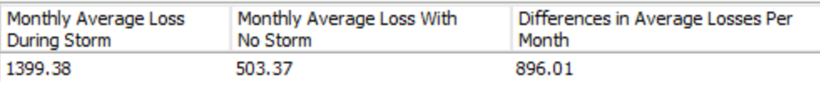

The Monthly Average Loss During Storms for the three-year period was greater than the Monthly Average Loss with No Storm. This is quantified by an average of $896,010 per month difference. This indicates that there was an average of $896,010 more in monetary losses to victims of crimes on days there was a storm than on days there was not a storm.

Using Excel, these numbers were able to be verified through averaging the columns in each of the original data sets for the total set, as well as for the months of the hurricane season and the months that are not during hurricane season. The numbers for the excel calculations are equivalent to those in the SQL queries, validating that the queries executed are accurate representations of the data. (See Appendix B.)

## IV. Drawing Conclusions

### 4.1 Present the results of the analysis to stakeholders

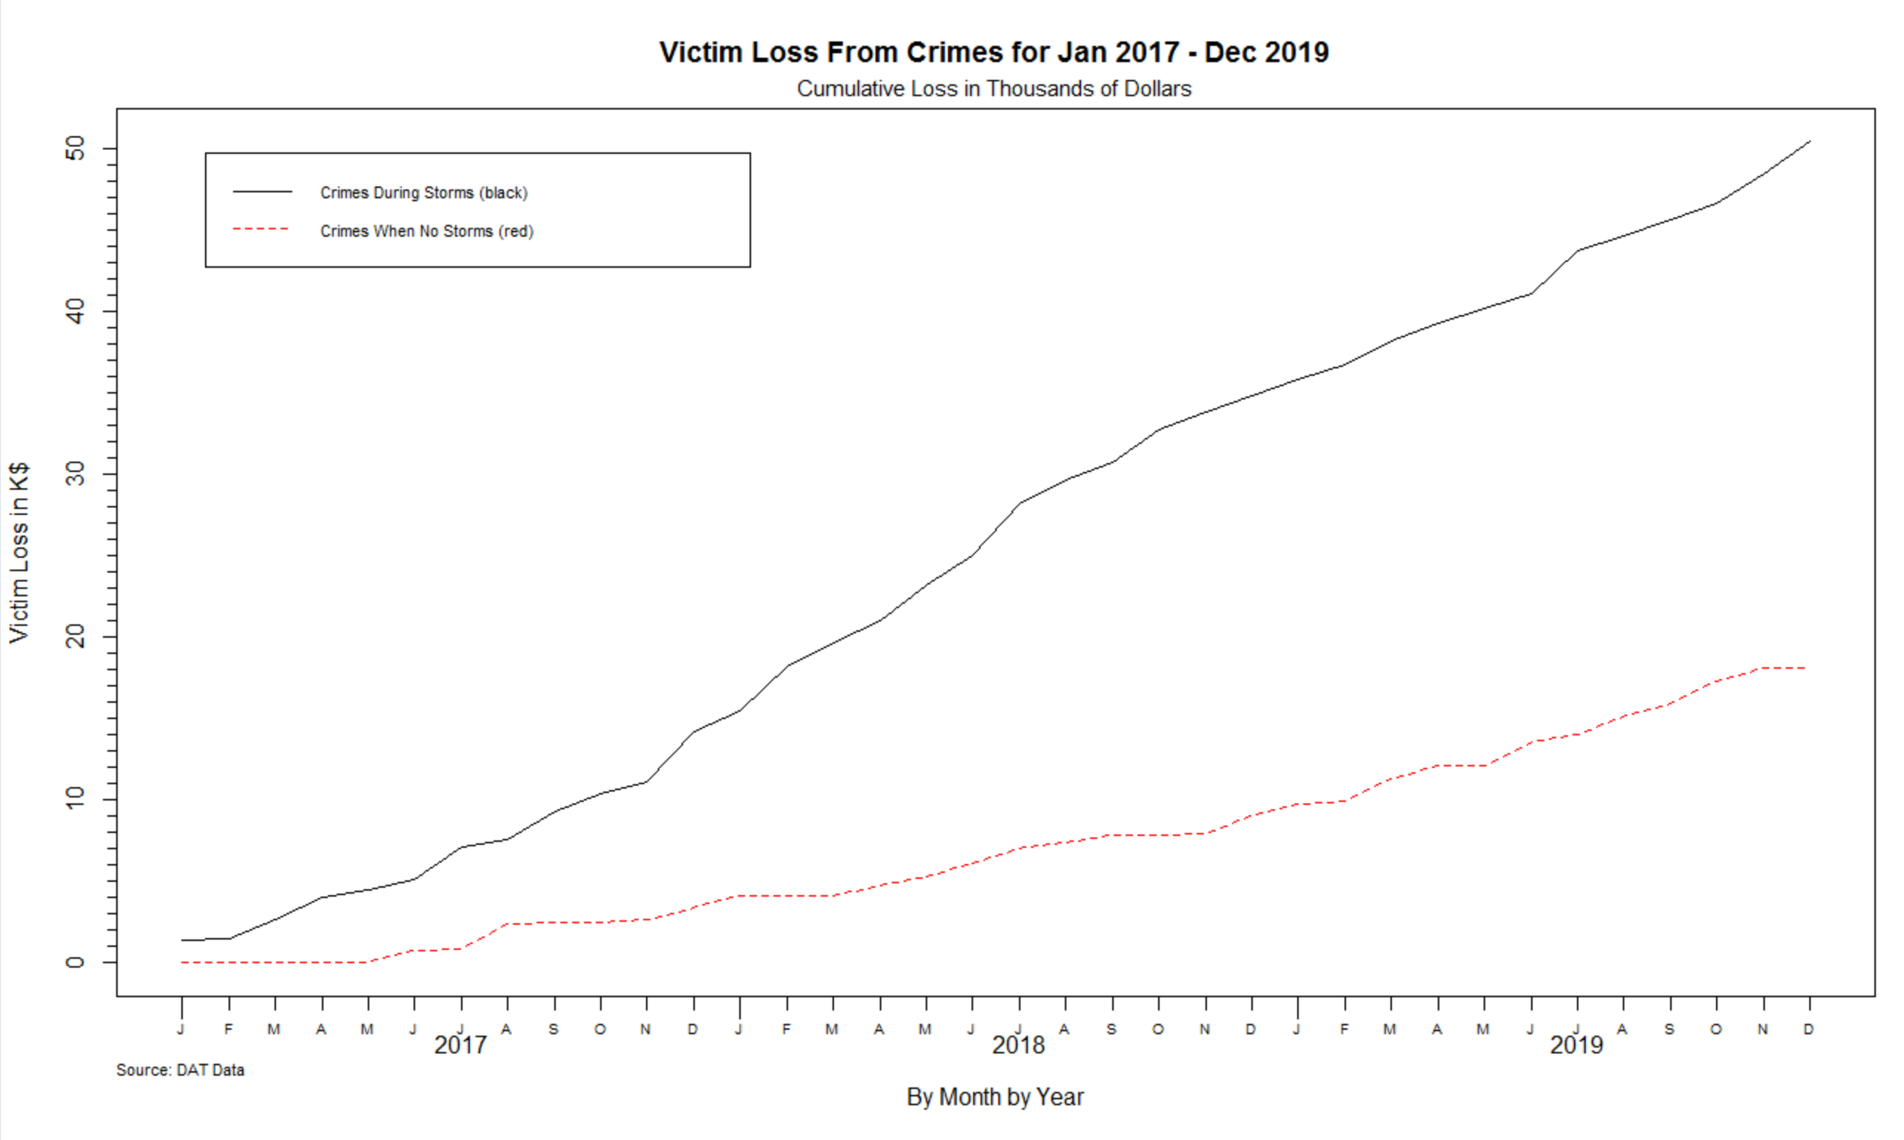

This graph shows the cumulative amount of losses incurred by victims over time. The red line indicates the losses from crimes that occurred when there was no storm. The black line is the losses to victims when there was a storm. Each line is additive to the data that precedes it, and never decreases. During times when there are no losses the line is more flat.

The graph shows that a clear trend for greater losses to victims of crime during storms than from crimes that occur when there are not storms. Each of the lines appears to be relatively linear with few sharp increases and minimal plateauing of the victim losses. As a predictive model, this would indicate an expectation for an increase at the same rate for both storm and non-storm days.

### 4.2 Determine whether the problem was addressed, including any challenges and limitations

Given the data that was provided, it was able to be ascertained when the crimes with the greatest monetary losses to victims occur relative to whether there was a storm on the day of the crime or not. Due to the limited data available, though, further elaboration upon this could not be extrapolated. The timing of the storms and the crimes would be a much more descriptive set of data points that could help this data with creating a clearer picture.

One of the limitations of this data is that it is unclear whether there are more or fewer storms each of the months as the number of storm days are not included in the data set. It is also not clear whether there is a greater number of crimes that occur during storms or if the losses are greater due to a smaller number of higher cost crimes. This would occur if, for example, there were a hurricane anticipated and a more affluent household left the area. A single robbery from that house may lead to significantly greater monetary loss than a hundred crimes on a non-storm day.

### 4.3 Report potential new findings

According to the NOAA (n.d.), the Atlantic hurricane season runs from June 1st to November 30th. The differences between the 6 months of hurricane season and the other 6 months of the year were evaluated with some remarkable differences. The total sum of losses during hurricane season was very close to that of the non-hurricane season. The overall monthly losses were greater during hurricane season, but the more noticeable difference was between the events that occurred when there was no storm at the time of the crime. This can be seen in the table below with the scripts utilized noted in Appendix A and validated in Appendix B.





This could be due to several factors. According to research by Drexel University (2017), hotter weather can contribute to an increase in violent crimes. Since hurricane season is during the summer months, this may contribute to the higher overall monetary loss to victims regardless of the timing of a storm. Additionally, in the day after a storm, there may be a greater propensity for crimes such as robbery when there is also property destruction related to a storm that leaves property vacant.

There have also been studies conducted on the aftermath of large storms, such as Hurricane Katrina. These studies lend credence to the idea that there may be a correlation between crime and the aftermath of storms, but that a lack of social controls as a result of the impact of the storms also plays a role (Varano et al., 2010, p. 43). This would indicate a disaster preparedness plan may be an effective way to reduce the impact of a significant storm, such as a hurricane, may have on the community and help maintain order.

References

Drexel University. (2017, September 25). *Violent crime increases during warmer weather, no matter the season, study finds*. ScienceDaily. https://www.sciencedaily.com/releases/2017/09/170925132948.htm

import.io. (2019, September 30). *Data Analysis: What, How, and Why to Do Data Analysis for Your Organization*. https://www.import.io/post/business-data-analysis-what-how-why/#:%7E:text=The%20process%20of%20data%20analysis,used%20to%20make%20informed%20decisions.

NOAA. (n.d.). *Tropical Cyclone Climatology*. NOAA.Gov. Retrieved October 18, 2020, from https://www.nhc.noaa.gov/climo/

Varano, S. P., Schafer, J. A., Cancino, J. M., Decker, S. H., & Greene, J. R. (2010). A tale of three cities: Crime and displacement after Hurricane Katrina. *Journal of Criminal Justice*, *38*(1), 42–50. https://doi.org/10.1016/j.jcrimjus.2009.11.006

### Appendix A

### Schema created called SCDR and data from the csv files was imported into the respective tables.

### create schema SCDR;

use SCDR;

CREATE TABLE `scdr`.`crimestormq` (`Date` text, `Loss` double);

CREATE TABLE `scdr`.`crimenostormq` (`Date` text, `Loss` double);

**Average of the column “Loss” was taken for all months of data in each of the tables. The difference from the Storm and NoStorm data was evaluated.**

### Select

### ROUND (AVG(crimestormq.Loss), 2) as 'Monthly Average Loss During Storm',

### ROUND (AVG(crimenostormq.Loss), 2) as 'Monthly Average Loss With No Storm',

### ROUND (AVG(crimestormq.Loss) - AVG(crimenostormq.Loss), 2) AS 'Differences in Average Losses Per Month'

### FROM crimenostormq

### INNER JOIN crimestormq

### ON crimenostormq.Date;

**The average from months that were identified as being during hurricane season were taken, with the hurricane season noted to be from June 1 through November 30.**

Select

ROUND (AVG(crimestormq.Loss), 2) as 'Average Monthly Loss During Storm in Hurricane Season',

ROUND (AVG(crimenostormq.Loss), 2) as 'Average Monthly Loss With No Storm in Hurricane Season',

ROUND (AVG(crimestormq.Loss) - AVG(crimenostormq.Loss), 2) AS 'Differences in Average Losses Per Month',

ROUND (SUM(crimestormq.Loss + crimestormq.Loss), 2) AS 'Sum of Losses During Hurricane Season'

FROM crimenostormq

INNER JOIN crimestormq

ON crimenostormq.Date

WHERE (crimenostormq.Date like '6/1/201%' AND crimestormq.DATE like '6/1/201%') OR

(crimenostormq.Date like '7/1/201%' AND crimestormq.DATE like '7/1/201%') OR

(crimenostormq.Date like '8/1/201%' AND crimestormq.DATE like '8/1/201%') OR

(crimenostormq.Date like '9/1/201%' AND crimestormq.DATE like '9/1/201%') OR

(crimenostormq.Date like '10/1/201%' AND crimestormq.DATE like '10/1/201%') OR

(crimenostormq.Date like '11/1/201%'AND crimestormq.DATE like '11/1/201%') ;

**The average from months that were identified as *not* being during hurricane season were taken, which would be from December 1 through May 31.**

Select

ROUND (AVG(crimestormq.Loss), 2) as 'Average Monthly Loss During Storm Not in Hurricane Season',

ROUND (AVG(crimenostormq.Loss), 2) as 'Average Monthly Loss With No Storm Not in Hurricane Season',

ROUND (AVG(crimestormq.Loss) - AVG(crimenostormq.Loss), 2) AS 'Differences in Average Losses Per Month',

ROUND (SUM(crimestormq.Loss + crimestormq.Loss), 2) AS 'Sum of Losses Not in Hurricane Season'

FROM crimenostormq

INNER JOIN crimestormq

ON crimenostormq.Date

WHERE (crimenostormq.Date like '1/1/201%' AND crimestormq.DATE like '1/1/201%') OR

(crimenostormq.Date like '2/1/201%' AND crimestormq.DATE like '2/1/201%') OR

(crimenostormq.Date like '3/1/201%' AND crimestormq.DATE like '3/1/201%') OR

(crimenostormq.Date like '4/1/201%' AND crimestormq.DATE like '4/1/201%') OR

(crimenostormq.Date like '5/1/201%' AND crimestormq.DATE like '5/1/201%') OR

(crimenostormq.Date like '12/1/201%'AND crimestormq.DATE like '12/1/201%') ;

Appendix B

Validation completed in Excel to indicate corresponding queries in MySQL were accurate.

CrimeNoStormQ

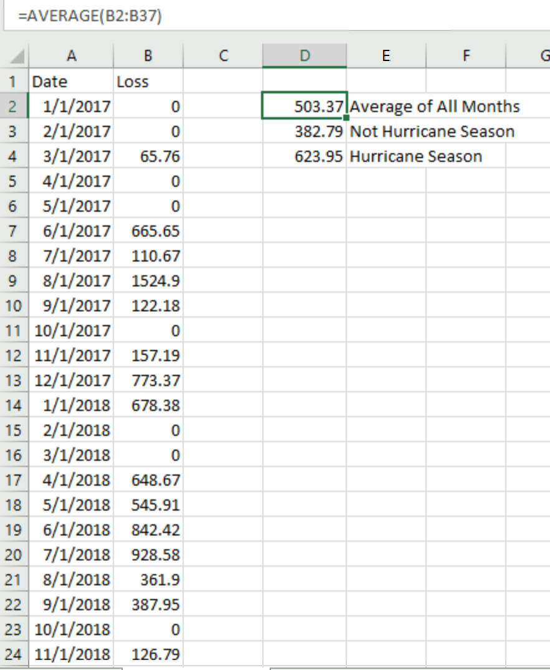

CrimeStormQ

